**WCP to perform various string operations.**

**String join operation**

Imports System

Module Program

Sub Main(args As String())

Dim sArr As String() = {"Welcome", "to", "VB.NET"}

Console.WriteLine("Join with Hypen: {0}" , String.Join("-", sArr))

Dim sArr1 As String() = {"Krishna", "Kishore", "Kiran"}

Console.WriteLine("Join with Comma: {0}" , String.Join(", ", sArr1))

Console.WriteLine("Press Enter Key to Exit.." )

Console.ReadLine()

End Sub

End Module

**Output:** 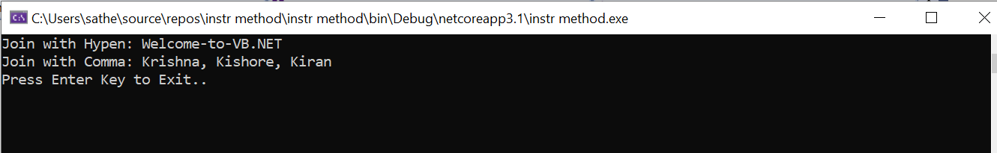

**String comparison operation**

Public Class Form1

Private Sub Button1_Click(sender As Object, e As EventArgs) Handles Button1.Click

Dim str1, str2 As String

str1 = "Abc"

str2 = "ABc"

MessageBox.Show(String.Compare(str1, str2, False))

MessageBox.Show(String.Compare(str1, str2, True))

End Sub

End Class

**Output**

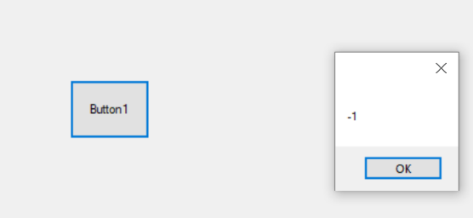

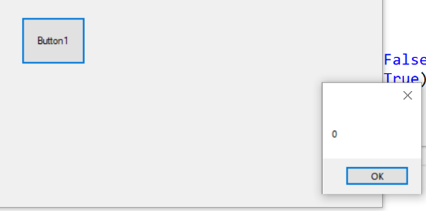

**Split Method**

Public Class Form1

Private Sub Button1_Click(sender As Object, e As EventArgs) Handles Button1.Click

Dim input As String = "one)(two)(three)(four)(five"

Dim result As String() = input.Split(New String() {")("}, StringSplitOptions.None)

For Each s As String In result

MessageBox.Show(s)

Next

End Sub

End Class

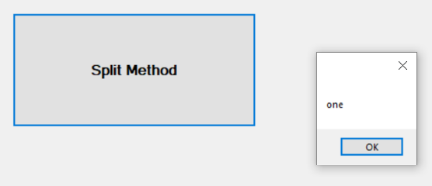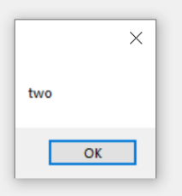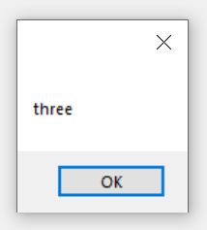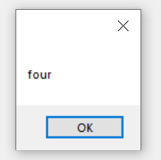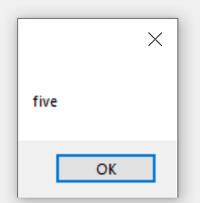

**Program to identify choice of user using select…case**

Public Class Form1

Private Sub lstData_SelectedIndexChanged(sender As Object, e As EventArgs) Handles lstData.SelectedIndexChanged

'what did we choose

Dim name As String

name = lstData.Items(lstData.SelectedIndex)

'use a select case to do something

Dim favoriteColor As String

Select Case name.ToLower()

Case “saheli”

favoriteColor = ”Purple”

Case “nainika”

favoriteColor = ”Green”

Case “saswati”

favoriteColor = ”Maroon”

Case “monalisa”

favoriteColor = ”Pink ”

Case “sucharita”

favoriteColor = ”Red”

Case “anchal”

favoriteColor = ”yellow”

Case Else

MessageBox.Show("We didnt mention" & name & "'s Favorite colour")

End Select

'display a message box…

MessageBox.Show(name & “’s favorite color is” & " " & favoriteColor, “Select Demo”)

End Sub

End Class

**Output:**

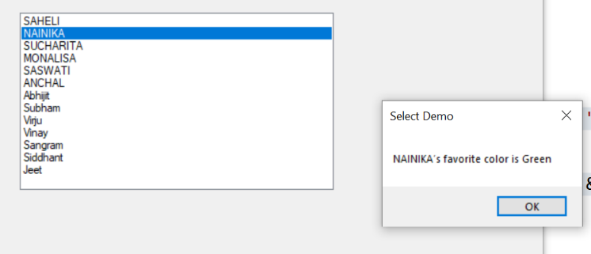

**Program to find the largest number among three numbers.**

Imports System

Module Program

Sub Main(args As String())

Dim first, second, third

Console.WriteLine("Enter your first number")

first = Console.ReadLine

Console.WriteLine("Enter your second number")

second = Console.ReadLine

Console.WriteLine("Enter your third number")

third = Console.ReadLine

If first > second And first > third Then

Console.WriteLine("Largest is " & first)

ElseIf second > third And second > first Then

Console.WriteLine("Largest is " & second)

Else

Console.WriteLine("Largest is " & third)

End If

Console.ReadKey()

End Sub

End Module

**Output:**

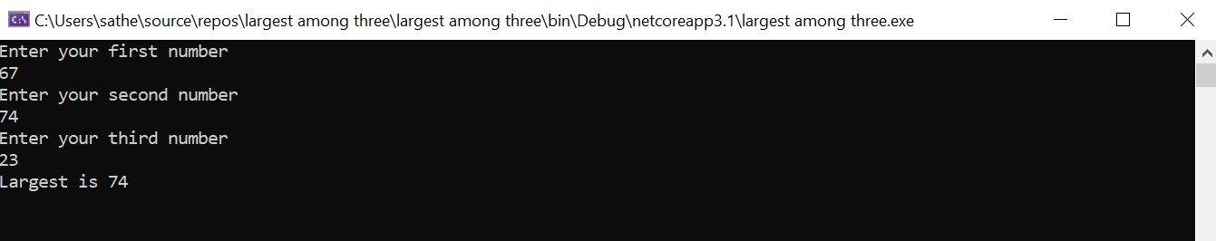

**Program to find maximum and minimum element in an array of size n**

Imports System

Module Program

Sub Main(args As String())

Dim n, i, min, max As Integer

Console.WriteLine("How many elements do you want to enter")

n = Console.ReadLine

Dim arr(n) As Integer

For i = 0 To n - 1

Console.Write("Enter the element " & (i + 1) & " ")

arr(i) = Int(Console.ReadLine())

Next

Console.WriteLine("Array Contains the follwing elements:")

For i = 0 To n - 1

Console.WriteLine(arr(i))

Next

min = arr(0)

max = arr(0)

For i = 0 To n - 1

If min > arr(i) Then

min = arr(i)

End If

Next

For i = 0 To n - 1

If max < arr(i) Then

max = arr(i)

End If

Next

Console.WriteLine("The minimum element in an array is" & min)

Console.WriteLine("The maximum element in an array is" & max)

End Sub

End Module

**Output:**

